Assessment Plan Reference: YYYY-MM-DD-ASP-AOID.001

# General Information

|  |  |  |  |  |  |  |  |
| --- | --- | --- | --- | --- | --- | --- | --- |
| Auditing Organization (AO) | Name of the Auditing Organization  {Head Office Address} | | | | | | |
| AO ID# |  | | | | | | |
| Contact Person | {Name, Title}  Tel.:  E-mail: | | | | | | |
| Assessment Team | Assessment Team Leader: {Name, Regulatory Authority}  Assessor: {Name, Regulatory Authority}  {As applicable: Role, Name, Regulatory Authority} | | | | | | |
| Assessment: | Initial  Surveillance {#}  Re-recognition  Other: Specify | | | | | | |
| Objectives | {see Instructions below – section 3} | | | | | | |
| Scope of the Assessment | Facility(ies) | Processes | | | | | |
| Management | Use of External Resources | Measurement, Analysis & Improvement | Competence Management | Audit & Certification Decision | Information Management |
| Head Office |  |  |  |  |  |  |
| Critical Location # |  |  |  |  |  |  |
| Critical Locations   Not Applicable | Critical Location #  {Name of the Critical Location}  {Address}  Contact person at the critical location:  {Name, Title}  {tel}  {e-mail}  *{if multiple Critical Locations covered by this assessment plan, duplicate the content of this cell and of the cell above to show specifics of all Critical Locations}* | | | | | | |
| Technical Areas | Refer to Attachment #1 *{attach PDF file of the technical areas tab from the Auditing Organization’s Assessment Program Management File (MS Excel workbook Medical Device Single Audit Program AS F0005.2)}* | | | | | | |
| Assessment Criteria | * ISO/IEC 17021-1:2015 – Conformity Assessment – Requirements for bodies providing audit and certification of management systems – Part 1: Requirements * IMDRF MDSAP WG N3 (2nd Edition) – Requirements for Medical Device Auditing Organizations for Regulatory Authority Recognition * IMDRF MDSAP WG N4 (2nd Edition) – Competence and Training Requirements for Auditing Organizations | | | | | | |
| Reference Documents | * MDSAP AS P0034: Regulatory Authority Assessment Method for the Recognition and Monitoring of Medical Device Auditing Organizations * MDSAP AU P0002 – MDSAP Audit Approach * MDSAP AU P0008 – Audit Time Calculation Procedure * MDSAP AU P0019 – MDSAP Regulatory Audit Report Policy * Australian Medical Device Regulations * MDSAP AU P0026 – Certification Document requirements * MDSAP AU P0027 – Post Audit Activities and Timeline * MDSAP AU P0028 – Expectations regarding Threat to Impartiality from Consultancy Services provided by Participating Auditing Organization * MDSAP AU P0029 – Communication by AOs with RA on Organizations Participating in MDSAP * MDSAP AU P0036 – Remote / Hybrid Auditing Program * MDSAP AU P0037 – Guidelines on the Use by MDSAP of document GHTF/SG3/N19:2012 – Nonconformity Grading System for Regulatory Purposes and Information Exchange * Brazilian Medical Device Good Manufacturing Practices (Resolution RDC 665/2022) * Brazilian Post-Market Surveillance and Medical Device Reporting (Resolution RDC 67/2009) * Brazilian Field Actions (Resolution RDC 551/2021) * Canadian Medical Device Regulations (applicable parts of SOR-98/282) * Japanese Medical Device Regulations (PMD Act) * Japanese QMS Ordinance (MHLW MO169) * US Medical Device Regulations (21 CFR parts 820, 803, 806, 807, 814 and 821) * Other: | | | | | | |
| On-site Assessment Dates | {YYYY-MM-DD to YYYY-MM-DD} | | | | | | |
| Assessment Language | English | | | | | | |

# Schedule

|  |  |  |  |
| --- | --- | --- | --- |
| **Day 1** | | | |
| Date | | {YYYY-MM-DD} | |
| Facility | | {Head Office, Critical Location #}*{may be removed if only 1 facility visited during the assessment}* | |
| Time | Assessor | Assessment Model Key Process and Assessment Step | AO’s Subject Matter Expert |
|  |  | {see instructions below – section 4} |  |
|  |  |  |  |
|  |  |  |  |
|  |  |  |  |
|  |  |  |  |
|  |  |  |  |
|  |  |  |  |
|  |  |  |  |

|  |  |  |  |
| --- | --- | --- | --- |
| **Day 2** | | | |
| Date | | {YYYY-MM-DD} | |
| Facility | | (Head Office, Critical Location #}*{may be removed if only 1 facility visited during the assessment}* | |
| Time | Assessor | Assessment Model Key Process and Assessment Step | AO’s Subject Matter Expert |
|  |  |  |  |
|  |  |  |  |
|  |  |  |  |
|  |  |  |  |
|  |  |  |  |
|  |  |  |  |
|  |  |  |  |
|  |  |  |  |

|  |  |  |  |
| --- | --- | --- | --- |
| **Day 3** | | | |
| Date | | {YYYY-MM-DD} | |
| Facility | | {Head Office, Critical Location #}*{may be removed if only 1 facility visited during the assessment}* | |
| Time | Assessor | Assessment Model Key Process and Assessment Step | AO’s Subject Matter Expert |
|  |  |  |  |
|  |  |  |  |
|  |  |  |  |
|  |  |  |  |
|  |  |  |  |
|  |  |  |  |
|  |  |  |  |
|  |  |  |  |

*{Add or remove day-schedule table as appropriate}*

*{Notes may be added as necessary. Example of note used on Standard Stage 2 Assessment:*

*Note: times specified in this assessment plan are indicative only. Should the assessment team need to extend the on-site assessment duration, it will communicate with the Auditing Organization to review the plan. The closing meeting may be postponed up to Day 4 around mid-day.}*

**Assessment Plan Transmittal and Review**

|  |  |
| --- | --- |
| Date issued | {YYYY-MM-DD} |
| APM’s Comments |  |
| AO’s Comments |  |

# Instructions on How to Use the Assessment Plan Form

Content

1. Preparation of the Plan
2. Convert the Document into a MS Word Fillable Form
3. Standard Text for Assessment Objectives
4. Standard Text for Assessment Schedule

## Preparation of the Plan

The form includes a few grey fields, including tick boxes. DO NOT REMOVE these fields.

To modify the corresponding information, double click on the grey field. This opens a window where the “default text” can be changed, or the status of a box switched from “unchecked” to “checked”.

The form includes information {between brackets} intended to help document the Assessment Plan. Text between brackets provides either clarification regarding information to include in the assessment plan {normal} or comments on the use of the form {*italic*}. Once the assessment plan is documented, remove any bracketed text as well as these Instruction pages.

Standard text for the Assessment Objectives and for the Assessment Schedule tables is included in sections 3 and 4 below. This standard text may be modified, if necessary, to adapt to the particular context of the assessment.

## Convert the Document into a MS Word Fillable Form

With MS Word 2003 or earlier, select in the menu View > Toolbars > Forms, and click on the lock button.

Note: Be aware that when the form if converted back to a normal document, the content of the fields may be lost.

With MS Word 2007 or later, the 1st time you need to perform this function, follow the following steps:

1. Select in the menu File > Options.
2. Select the tab Customize Ribbon.
3. In the “Chose commands from” field, select “Commands Not in the Ribbon” and scroll down to find the “Lock” function (with the “Padlock” icon)
4. In the “Customize the Ribbon” field, select the tab where you want to add the new button. Click on “New Group”, select this New Group.
5. Click on the “Add” button. A new button appears in the selected ribbon, identified by the Padlock icon and the title “Lock”, which will always be there unless voluntarily removed. The steps 1 to 5 are unnecessary the next time an assessment plan is prepared.

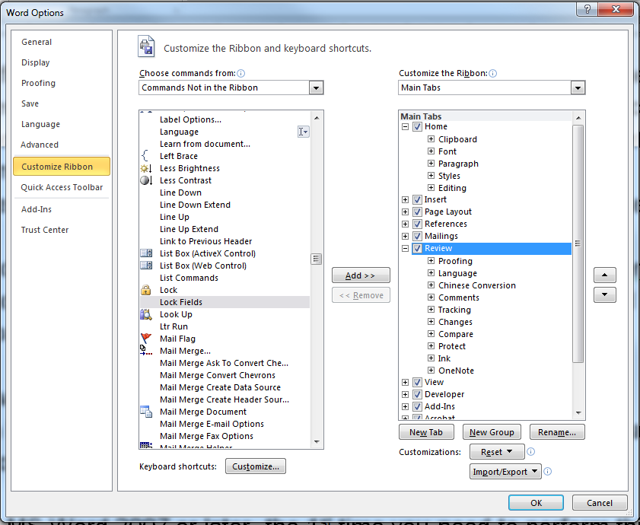

1. Click on the “Lock” button to convert the document into a fillable form.

Note: A password may be specified but it is not necessary.

Once converted, the only areas of the document that can be modified are the grey fields.

Save the file and send it to the Contact Person at the Auditing Organization and to the Assessment Program Manager.

## Standard Text for Assessment Objectives

|  |  |
| --- | --- |
| Assessment Type | Assessment Objectives |
| Stage 2 Assessment | * + Evaluate the conformity of the Auditing Organization’s management system documentation to meet all the regulatory requirements including IMDRF MDSAP WG N3 and N4 documents;   + Evaluate the evidence of implementation, monitoring, measuring, reporting and reviewing by the Auditing Organization of its activities against policies, procedures and objectives from its management system (consistent with the expectations for recognition);   + Review the operational controls of the Auditing Organization’s processes, including when implemented by external resources;   + Confirm that the Auditing Organization conducted internal audits and management reviews; and   + Confirm the competence of the Auditing Organization and the resources available necessary to fulfill the obligations for the scope of recognition. |
| Surveillance Assessment | * + Review of internal audits and management review;   + Review of Competence Management activities;   + Review of actions taken on nonconformities identified during the previous audit;   + Treatment of complaints and appeals;   + Evaluation of the effectiveness of the management system with regard to achieving the Auditing Organization’s objectives as it relates to the scope of recognition;   + Evaluate records of audit and decision on conformity of medical device manufacturer to regulatory requirements;   + Evaluate continuing operational control; and   + Review any changes. |
| Re-recognition Assessment | * + Evaluate the effectiveness of the Auditing Organization’s management system in its entirety in the light of internal and external changes and its continued relevance and applicability to the scope of recognition;   + Confirm the continued conformity of the Auditing Organization’s management system to regulatory requirements including IMDRF MDSAP WG N3 and N4 documents; and   + Confirm the commitment of the Auditing Organization to maintain the effectiveness of the management system. |
| Assessment of Critical Location | * + Review the relationship between the head office of the Auditing Organization and the Critical Location;   + Review, if applicable, the arrangements between the head office of the Auditing Organization and the Critical Location;   + Evaluate the management system operated at the critical location to satisfy the requirements of the Auditing Organization;   + Evaluate the conformity of the activities undertaken by the Critical Location on behalf of the Auditing Organization to the requirements of the Auditing Organization’s management system or to the arrangements between the head office of the Auditing Organization and the Critical Location;   + Evaluate the conformity of activities undertaken by the Critical Location on behalf of the Auditing Organization to the corresponding regulatory requirements including IMDRF MDSAP WG N3 and N4 documents; and   + Evaluate the controls in place at the Critical Location enabling its monitoring by the Auditing Organization. |

## Standard Text for Assessment Schedule

|  |
| --- |
| Opening meeting |
| Closing meeting |
| Lunch break |
| Assessors’ private debriefing |
| End of the day summary briefing |
| Follow-up of findings from prior assessment days |

|  |
| --- |
| **Process: Management**   1. Legal entity, legal responsibility liability, financing & eligibility 2. Quality Management System documents 3. Quality policy, quality objectives and quality planning 4. Organizational structure, responsibility, authority 5. Adequacy of auditing resources 6. Management of impartiality 7. Management review |
| **Process: Use of external resources**   1. Extent of use and controls of external resources 2. Contractual arrangements with external resources 3. Internal competence to review the outcome of outsourced activities |
| **Process: Measurement, Analysis & Improvement**   1. Procedures relative to measurement, analysis and improvement 2. Sources of quality data 3. Investigation, corrections, corrective actions and preventive actions to address nonconformities and potential nonconformities 4. Reporting of corrective actions impacting the recognition 5. Decision on conformity to regulatory requirements supported by nonconforming audit or audit reports 6. Internal audits 7. Complaint handling and management 8. Communication with external resources having contributed to a nonconformity or complaint 9. Outputs of the Measurement, Analysis and Improvement process as inputs into the management review |
| **Process: Competence Management**   1. Identification of necessary competence to operate as a recognized auditing organization 2. Procedure and criteria for competence evaluation of all personnel involved in audit and certification related activities 3. Identified personnel with demonstrated competence 4. Training to the audit process and certification requirements and access to corresponding current documents 5. Monitoring of personnel’s competence and performance 6. Personnel’s individual file 7. Effectiveness of the competence evaluation methods and the competence management process |
| **Process: Audit & Decision**   1. Procedures for the control of the Audit & Decision Process 2. Audit program establishment and update; audit time determination; planning of audits 3. Selection and assignment of competent audit team, and communication prior to the audit 4. Audit performance and audit report 5. Review of correction and corrective action initiated in response to audit findings 6. Technical review of the audit file and decision making on regulatory conformity of the manufacturer 7. Implementation and follow-up of the decision, including unannounced audits 8. Appeals 9. Audit and decision records 10. Effectiveness of the Audit and Decision process |
| **Process: Information Management**   1. Control of documents and records 2. Public information on the audit program 3. Provision to the audited medical device manufacturers of detailed information on the audit and decision related processes 4. Contractual agreements with the audited medical device manufacturer 5. Sharing of information with recognizing Regulatory Authorities on auditing activities, decisions on regulatory compliance and certification status 6. Provision to the public of information on certification status or certifications granted, suspended or withdrawn 7. Control of confidential information |